INSTRUCTIONS: This is an SOP template; it is complete when
1) All form fields have been completed to reflect chemical/lab-specific information, including adding relevant procedure information, or deleted inapplicable information; and
2) SOP has been signed and dated by the PI and relevant lab personnel.
Use safety data sheets (SDSs) as a resource for chemical-specific information. Text highlighted in gray indicates where information should be added or edited. Delete all instructions in red text and “Draft” watermark after the SOP is approved by PI.
Standard Operating Procedure
Acid Piranha Solution
Print a copy and insert into your Lab-Specific Chemical Hygiene Plan.
Section 1 – Lab-Specific Information
Building/Room(s) covered by this SOP:
Unit or department:
Principal Investigator Name:
Principal Investigator Signature/Date:
This SOP was created by (if not PI):
Name/Title/Date/Signature

Section 2 – Hazards
"Piranha" is a highly corrosive and strongly oxidizing solution that is typically used to remove organic residues from glassware and to etch metals. It is extremely energetic and may result in an explosion or injury from chemical and thermal burns if not handled with caution. Acid Piranha is a ≥3:1 mixture of concentrated sulfuric acid (H2SO4) with 30% hydrogen peroxide (H2O2). When combined, H2SO4 and H2O2 will self-heat to a boil, causing the solution to become active. Acid Piranha Solution should never be used for routine cleaning. Consult with PI or supervisor before using Acid Piranha Solution for the first time.
NOTE: Base Piranha, also known as RCA SC-1, is a 3:1 mixture of ammonium hydroxide (NH4OH) and H2O2, which must be heated to become active. The applications of Acid vs. Base Piranha vary greatly. This SOP addresses only the hazards of Acid Piranha; Base Piranha is not covered herein.
Piranha solutions will oxidize any carbon species (sans diamond), producing carbon dioxide gas. Besides oxidizing and removing organic matter, Piranha will also hydroxylate most surfaces (add OH groups). Gross contamination by various organic species (e.g., acetone, photoresist, isopropyl alcohol, nylon, etc.) can result in explosions when in contact with Piranha solutions.
Direct exposure will cause serious tissue damage and immediate pain. Piranha vapors are strongly corrosive and will irritate the respiratory tract if vapors are inhaled. The severity of damage depends on the duration of exposure and the body parts contacted.
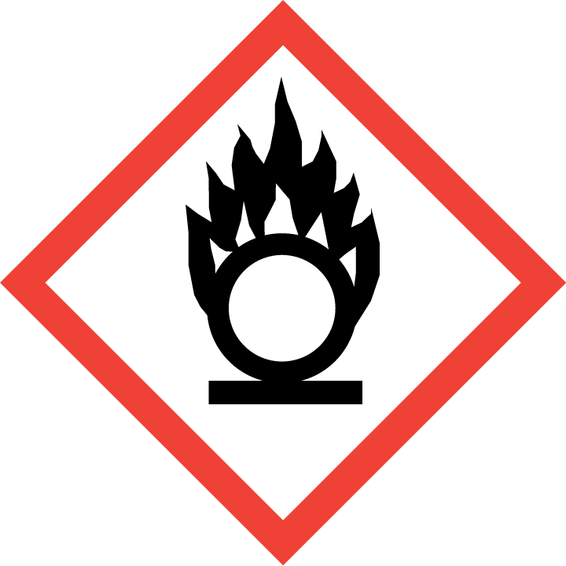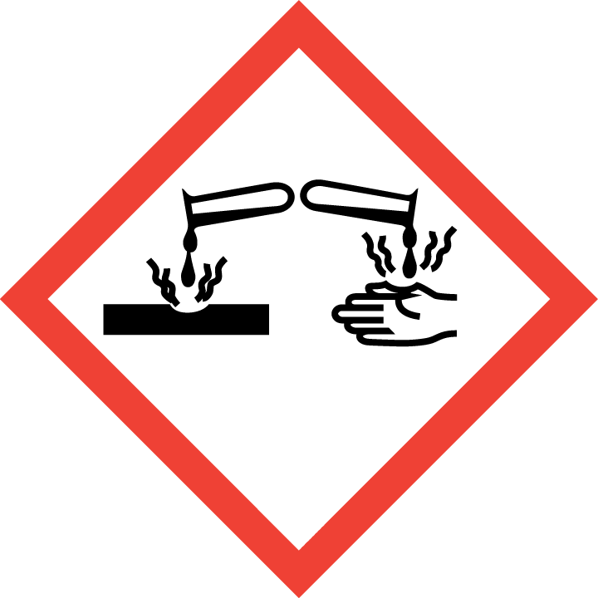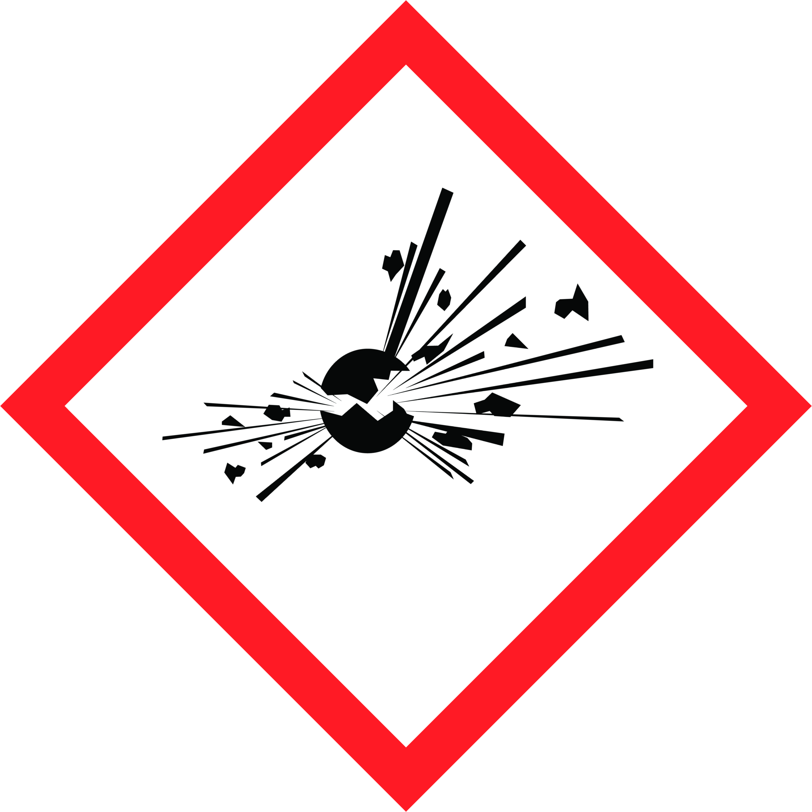
Section 3 – Engineering and Personal Protective Equipment (PPE)
REQUIRED - Insert descriptions and locations of lab-specific ventilation controls and equipment utilized to reduce the risk of Acid Piranha chemical exposures.
Engineering Controls: All work involving Acid Piranha must be conducted in a properly functioning chemical fume hood whenever possible. The chemical fume hood must be approved for use by EH&S. The fume hood sash should be between the researcher and the Piranha solution whenever practical to minimize the chance of injuries from splashing.
Using corrosives and strong oxidizers at elevated temperatures may require facility-specific engineering/ventilation controls. Contact UW EH&S at labcheck@uw.edu for guidance.
Details:

Hygiene Measures: In addition to the minimum attire required upon entering a laboratory, the following PPE is required for all work with Acid Piranha. Note that if Acid Piranha comes into contact with any PPE, the PPE shall be immediately removed and discarded properly. Any potentially exposed body parts should be washed immediately with tepid water for 15 minutes.
REQUIRED - Insert the lab-specific gloves or glove combination that are required for use with Acid Piranha Solution. When possible, include the exact manufacturer and model information.
Hand Protection: Hand protection is required for the activities described in this SOP. Thick (≥10 mil), chemically resistant gloves should be worn (a single layer of disposable Nitrile gloves will not provide sufficient protection). Define the type and thickness of glove to be used based on: A) the chemical(s) being used, B) the anticipated chemical contact (e.g., incidental, immersion, etc.), C) the manufacturers’ permeation/compatibility data, and D) whether a combination of different gloves is needed for any specific procedural step or task. NOTE: Consult with your preferred glove manufacturer to ensure that the gloves you plan on using are compatible with the specific chemical being used.
Gloves must be inspected prior to use, including a check for pinholes.
Details:

Eye Protection: Eye protection is required for all work with Acid Piranha. Eyewear must be ANSI Z87.1-compliant. At a minimum, safety glasses are necessary. Splash goggles may be substituted for safety glasses, and are required for processes where splashes are foreseeable or when generating aerosols. A full face shield should be worn when splashing is foreseeable. Ordinary prescription glasses will NOT provide adequate protection.
Skin and Body Protection: Chemically compatible laboratory coats that fully extend to the wrist must be worn and be appropriately sized for the individual and buttoned to their full length. If a risk of fire exists, a flame-resistant laboratory coat that is NFPA 2112-compliant should be worn. Some FR fabrics (e.g., Nomex®, Rhovyl®, Kevlar®, etc.) are highly permeable and do not provide good chemical/acid resistance. Personnel must also wear full-length pants, or equivalent, and close-toed shoes. The area of skin between the shoe and ankle must not be exposed. For chemicals that are corrosive and/or toxic by skin contact/absorption additional protective clothing (e.g., face shield, chemically-resistant apron, disposable sleeves, etc.) are required where splashes or skin contact is foreseeable.
Disposable sleeves and an acid-resistant apron are required where splashes or skin contact is foreseeable.
If handling large quantities (greater than 500 mL) an acid-resistant apron shall be worn.
Details:

Respiratory Protection: Respirators should be used as a last line of defense (i.e., after engineering and administrative controls have been exhausted), when Permissible Exposure Limit (PEL) has been exceeded, when there is a possibility that PEL will be exceeded, or as PPE in the event of a chemical spill clean-up process. If this activity is necessary, contact EH&S at 206.543.7388 so a respiratory protection analysis can be performed.
Section 4 – Special Handling and Storage Requirements
- Do NOT work alone with Piranha solutions;
- Do not deviate from the instructions described in this SOP without prior discussion and approval from the PI and/or Laboratory Supervisor;
- Notify the PI or Laboratory Supervisor of any accidents, incidents, near-misses, or upset condition (e.g., unexpected rise or drop in temperature, color or phase change, evolution of gas) involving the process, hazardous chemical(s), or hazardous chemical class described in this SOP.
- Acid Piranha must only be used in a room with a properly functioning eyewash. A safety shower must be available within 10 seconds of travel;
- Do not remove the Acid Piranha solution from the fume hood where it was made;
- Never put Acid Piranha solution (cold or hot) in a sealed container as catastrophic failure can occur due to gas generation and over pressurization. All waste bottles must have a vented cap;
- Do not use H₂O₂ solutions with concentrations greater than 30%. Higher concentrations of H2O2 can cause explosions;
- Always add hydrogen peroxide (H₂O₂) to sulfuric acid (H₂SO₄), never vice versa. Perform the addition slowly to prevent uncontrolled boiling and potential splashing. Given the viscosity of sulfuric acid, gentle stirring can also be helpful;
- Whenever preparing/handling Acid Piranha, only use clean glass containers (preferably borosilicate). All containers must be very clearly labeled;
- A warning sign, visible by any user working in the area, must be posted at all times to indicate the solution contains an Acid Piranha mixture;
- Materials to be cleaned/etched should be rinsed and dried before placing them in an Acid Piranha bath;
- Unless absolutely necessary, organic compounds and other flammable materials should be removed from the fume hood before working with Acid Piranha;
- No other work should be carried out in the fume hood whenever active Acid Piranha solution is present;
- Do not store Acid Piranha solution. Prepare a fresh solution for each use and only as much as needed for the specific use; and
- You must have a container of clean dry sand available for any Acid Piranha spills.
REQUIRED - Insert descriptions of any additional administrative controls (e.g., restrictions on procedure/quantity/work equipment/work locations/unattended operations/etc.), including controls that may be chemical-specific (e.g., peroxide formers).
Details:

Section 5 – Spill and Accident Procedures
You must notify EH&S of any Acid Piranha incidents or spills.
Spills of Acid Piranha require detailed spill response and must be cleaned up immediately by properly protected and trained personnel. All other persons should leave the area. Spill response procedures must be developed based on the chemical and potential spill or release conditions and using the appropriate spill kit. Do not attempt to clean up any spill if not trained or comfortable.
No spills outside of a chemical fume hood may be cleaned up by laboratory personnel.
Exposures: If a person is injured, exposed, or suspected of being exposed to Acid Piranha, follow procedures listed here. Bring this SOP and Safety Data Sheets (SDSs) for sulfuric acid and hydrogen peroxide with you to show medical personnel.
Skin exposure: remove contaminated clothing and shoes, rinse for 15 minutes in the safety shower and wash skin with soap. Send someone to call 911 as soon as possible.
Eye exposure: call 911 as soon as possible, remove contact lenses, and flush eyes for at least 15 minutes in the eyewash while holding upper and lower eyelids open. Place an ice pack on eyes during transport to hospital.
Inhalation: exposed persons should be moved to fresh air immediately. Seek medical attention in the event or respiratory irritation, cough, or tightness in chest. Symptoms may be delayed.
Ingestion: do not induce vomiting and call 911 as soon as possible.
Immediately evacuate area if fumes present a serious health risk or a large spill occurs; ensure others are aware of the spill. Avoid breathing fumes. During normal business hours (Monday – Friday, 8 AM – 5 PM), call EH&S at 206.543.0467 for further assistance. If it is after hours, call 911 for further assistance. If possible, confine the spill to a small area using clean dry sand. Keep others from entering contaminated area (e.g., use caution tape, barriers, etc.).
Spill procedures for small spills (< 500 mL) within the fume hood:
Trained personnel must clean up immediately using appropriate personal protective equipment listed above and clean-up material for chemical spilled. All other persons should leave the area. Prevent the spread of the Acid Piranha spill by encircling it with a layer of clean dry sand. Close the fume hood sash and wait until the reaction has gone to completion before proceeding. Once the reaction is complete, slowly and carefully neutralize the remaining Acid Piranha. Do not use combustible organic materials (spill pads or paper towels) absorb the spill without first neutralizing to a confirmed pH of 6-8. Collect spill cleanup materials, double bag and securely fasten spill materials. Label with a hazardous waste label that reads “Acid Piranha spill debris, contains sulfuric acid and hydrogen peroxide.” Complete either an Online Chemical Waste Collection Request or a Chemical Collection Request Form found on the EH&S website. Email the form to chmwaste@uw.edu
Clean the spill area thoroughly with detergent solution followed by clean water. If spill is extensive within the containment, clean all interior surfaces after completion of the spill cleanup.
Spill procedures for large spills (> 500 mL) or any amount outside of the fume hood:
No spills outside of a chemical fume hood should be cleaned up by laboratory personnel.
Immediately evacuate area; ensure others are aware of the spill. Avoid breathing fumes. Attend to injured or exposed persons using emergency shower or eyewash following procedures listed above under Exposures. If possible, confine the spill to a small area with clean dry sand. Keep others from entering contaminated area (e.g., use caution tape, barriers, etc.).
As soon as possible, report the spill in a safe area by notifying EH&S at 206.543.0467 for further assistance during normal business hours (Monday – Friday, 8 AM – 5 PM). If it is after hours, call 911 for further assistance. Tell them that a spill has occurred, and you need help managing the spill. EH&S can arrange for a spill cleanup contractor. Notify Supervisor.
Be prepared to provide the following information:
- Name and phone number of knowledgeable person that can be contacted
- Name of chemical spilled, concentration and amount spilled, liquid or solid type spill
- Number of injured, if any
- Location of spill
Report all spills via the EH&S Online Accident Reporting System (OARS) within 24 hours (8 hours if serious injury or hospitalization).
REQUIRED - Insert descriptions of any specialized spill clean up procedures for materials used in this SOP, including the procedures for corrosive spill cleanup. Additional details of lab-specific spill cleanup should be provided if applicable.
INSERT IF APPLICABLE - Descriptions of any specialized emergency procedures for locations outside of a UW campus or facility.
Section 6 – Waste Disposal Procedures
Double bag all spill waste in plastic bags labeled with a hazardous waste label that reads "Acid Piranha spill debris.” Complete either an Online Chemical Waste Collection Request or a Chemical Collection Request Form on the EH&S website. Email the form to chmwaste@uw.edu Store hazardous waste in a designated area in a certified fume hood. Decontaminate equipment, hood, and bench tops using soap and water.
DO NOT COMBINE ANY OTHER WASTE SOLUTION WITH SPENT ACID PIRANHA SOLUTION. Mixing Acid Piranha with organic compounds can cause an explosion. Oxygen released from self-decomposition and oxidation byproducts of organic compounds can cause storage containers to over pressurize and explode.
All used and excess Acid Piranha solution should be cooled to ambient temperature before being collected and stored as hazardous waste using the procedure described below.
Avoid having excess unused solution. If any excess unused Acid Piranha Solution remains at the end of the day or at the end of the procedure, whichever comes first, wait for the solution to fully cool to ambient temperature. Once the solution has cooled completely, carefully add to the waste container using the procedure described below.
Be sure the waste container is a suitable compatible material (e.g., clear glass or a recycled sulfuric acid bottle) and has a vented cap or other mechanism to prevent the build-up of pressure. Initially only add a small amount of the solution to the waste container to ensure there are no residual materials in the container that may cause an adverse reaction, realizing the adverse reaction may take minutes to hours to manifest. If no reaction is observed, continue to pour slowly. At least 25% of the container volume should be left empty. The container shall be labeled as “Acid Piranha Solution: Corrosive, Oxidizer, Toxic” in addition to listing all components (sulfuric acid, hydrogen peroxide, etc.) on the appropriate hazardous waste label. A vented cap must be used on the waste container and the container must be stored in a certified fume hood. DO NOT STORE ACID PIRANHA LONG TERM. Contact EH&S for pickup of Acid Piranha waste in a timely manner. Note: vented caps will not be returned after collection.
Upon completion of work with Acid Piranha and/or decontamination of equipment and work area, remove gloves and/or PPE to wash hands and arms with soap and water. Additionally, upon leaving a designated Acid Piranha work area remove all PPE worn and wash hands, forearms, face and neck as needed.
Contaminated clothing and PPE should not be removed from the laboratory, and should undergo proper decontamination or disposal.
REQUIRED - Insert descriptions of laboratory-specific information on the waste streams generated, storage location, and any special handling/storage requirements.
REQUIRED - Insert descriptions of decontamination procedures for equipment, glassware, and controlled areas (e.g., glove boxes, restricted access hoods, perchloric/hot acid fume hoods, or designated portions of the laboratory).

Section 7 – Protocol (Add lab specific Protocol/Procedure here)
Prepare only as much Acid Piranha Solution as is needed for a specific application; do not store the solution. Acid Piranha is prepared by slowly adding one volume of ≤30% H₂O₂ to ≥3 equivalent volumes of H₂SO₄ in a suitable glass vessel. Upon mixing, the colorless solution will self-heat to a boil. If large amounts of the solution are required, secondary containment in an ice bath may be necessary. The mixed solution can be directly applied to the substrate in open or vented glass vessels. Alternatively, H₂SO₄ can be first applied to the substrate, followed by ≤30% H₂O₂. To be effective, Acid Piranha solutions should be prepared and used within several hours. Allow the Acid Piranha reaction to proceed to completion and the solution to cool to ambient temperature.
REQUIRED - Insert or attach detailed laboratory-specific procedures for the process, hazardous chemical(s), or hazard class. You may also include any relevant supporting resources such as journal citations, etc. that are applicable.
Click here to enter text.
NOTE: Any deviation from this SOP requires approval from Principal Investigator.

Section 8 – Documentation of Training (signature of all users is recommended)
- Prior to using Acid Piranha Solution, laboratory personnel must be trained on the hazards described in this SOP, how to protect themselves from the hazards, and emergency procedures.
- Ready access to this SOP and to a Safety Data Sheet for each hazardous material described in the SOP (Sulfuric Acid, Hydrogen Peroxide, and other substances used in the process) must be made available in the location where the chemical is used.
- The Principal Investigator (PI), or the Responsible Party, must ensure that their laboratory personnel have completed lab-specific training and completed EH&S’s Managing Lab Chemicals training (and refresher training where applicable).
- Training must be repeated following any revision to the content of this SOP. Training must be documented. This training sheet is provided as one option; other forms of training documentation (including electronic) are acceptable but records must be accessible and immediately available upon request.
I have read and understand the content of this SOP:
Name | Signature | Date

